- Sample Information
Sample ID | R/2024050001 A
Sample Name | Air Limbah (Wastewater)
Storage Loc | Chiller 01 - Rak B
Condition | Intact, 4ºC
Turn Around Time (TAT) | 28 Jan 2026

- Test Assignments
No | Parameter | Analis | Alat/Instrumen | Due Date
1 | Logam Berat – Arsen (As) | Farrel A | ICP-OES | 12/2/2025
2 | Logam Berat – Cadmium (Cd) | Farrel A | ICP-OES | 12/2/2025
3 | Logam Berat – Kromium (Cr-VI) | Farrel A | ICP-OES | 12/2/2025
4 | Logam Berat – Tembaga (Cu) | Farrel A | ICP-OES | 12/2/2025
5 | Logam Berat – Besi (Fe) | Farrel A | ICP-OES | 12/2/2025
6 | Logam Berat – Timbal (Pb) | Farrel A | ICP-OES | 12/2/2025
7 | Logam Berat – Mangan (Mn) | Farrel A | ICP-OES | 12/2/2025
8 | Logam Berat – Merkuri (Hg) | Farrel A | ICP-OES | 12/2/2025
9 | Logam Berat – Seng (Zn) | Farrel A | ICP-OES | 12/2/2025
10 | Logam Berat – Nikel (Ni) | Farrel A | ICP-OES | 12/2/2025
11 | Logam Berat – Selenium (Se) | Farrel A | ICP-OES | 12/2/2025
12 | Logam Berat – Kobalt (Co) | Farrel A | ICP-OES | 12/2/2025
13 | Derajat Keasaman (pH) | Kelvin E | ICP-OES | 12/2/2025
14 | Chemical Oxygen Demand (COD) | Kelvin E | Spektrofotometer UV-VIS | 10/2/2025
15 | Total Suspended Solid (TSS) | Kelvin E | Gravimetri | 12/2/2025
16 | Minyak & Lemak | Kelvin E | Gravimetri | 12/2/2025

Assigned By:
Supervisor,
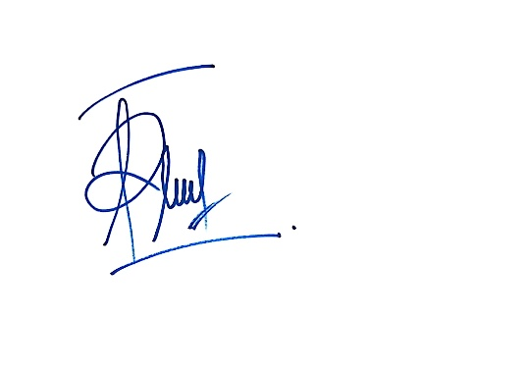
Farrel Arya Andhika

